|  |
| --- |
| By David Ngolehori and Yehor Tymoshenko |
| CRITICAL DESIGN DOCUMENT |
| Automatic Indoor Grow Enclosure |

|  |
| --- |
| EETD 4001  2024-12-11 |

Table of Contents:

Concept of operations: 1

Requirements: 1

Project Breakdown: 3

Final Code: 4

Hardware Design: 5

Test Procedures: 11

# Concept of operations:

Our project is about making Automatic Indoor Grow Enclosure (A.I.G.E.) the task of which is to keep plant growing in required conditions for it to develop healthy. Main functionalities consist from watering the plant, regulating temperature and humidity, giving light at specific time, have a constant airflow and show desired measurements on screen.

Display will show the important readings (Moister, Humidity, Vapor Pressure Deficit, and Temperature) to monitor the life of the plant in its vegetation stage. Will be updated and shown in real-time. Device will have initial setup by allowing user to choose desired temperature, humidity and moisture with buttons, through prompts when the device gets turned on.

Sensors will help with detecting and adjusting thevapor pressure deficit (VPD) level stable. VPD helps you identify the correct range of temperature and humidity to aim for in your grow space. Our ideal value for VPD would be around 1 kPa and we should make our value as close to it as possible to this, it should be no lower than 0.8 kPa and not bigger than 1.5 kPa.

# Requirements:

1. **LCD Display:**
   1. Shall incorporate an LCD display that is backlit and has 4 rows and can fit 20 characters in each line.
   2. Shall display the soil moisture level.
   3. The soil moisture level shall be shown as a percentage.
   4. Shall display the current temperature of the enclosure
   5. The enclosure’s temperature shall be shown in Celsius.
   6. Shall display the air vapor pressure deficit (VPD).
   7. VPD shall be calculated from configured values and measured values.
   8. The air vapor pressure deficit shall be shown as a ratio in kilopascals.
   9. Interface to the LCD shall be via the UART peripheral.
   10. LCD shall show prompt on initial configuration of humidity.
   11. LCD shall show prompt on initial configuration of moisture.
   12. LCD shall show prompt on initial configuration of temperature.
   13. LCD shall show error screen in situation in which humidity and temperature are not compatible, producing poor VPD.
2. **Temperature, humidity and moisture regulation system:**
   1. Temperature shall be measured with a sensor in Celsius.
   2. Humidity shall be measured with sensor to determine the relative humidity in percentage.
   3. A fan shall be used to aid in circulating airflow for temperature and humidity.
   4. Fan shall turn on automatically to help circulate airflow
   5. Fan shall be triggered when either humidity or temperature is above initial values made from LCD setup prompts.
   6. Fan shall be controlled from the PIC.
   7. Moisture sensor shall be placed bellow the indicated white warning line in soil.
   8. Pump shall irrigate the plant.
   9. Pump shall be controlled from the PIC
   10. Pump shall start watering when moisture goes lower than desired when sensed.
   11. Water tubing should be long enough to get from pump to enclosure.
   12. Water shall be stored in the container.
   13. Container should hold at least a liter of water.
   14. Container should not be bigger than five liters for practicality.
   15. Sensors shall be put on cables, so that they can be put into the enclosure for the plant.
3. **Enclosure for the plant:**
   1. There shall be an enclosure that can fit the desired plants.
   2. Enclosure shall be 30cm x 30cm x 50cm.
   3. Enclosure shall fit the desired plant.
   4. There shall be Grow light for heat and light for plants.
   5. The light will turn off and on automatically.
   6. The light should be independent from our other circuits.
   7. Enclosure shall have mounting for fans, lights, cables for sensors and water tubing.
   8. Enclosure will have small ventilation for circulating air.
   9. There will be a fan for just air circulation.
4. **Enclosure for electronics and LCD display:**
   1. There shall be an enclosure to store main logic components for the system to work.
   2. Enclosure shall be a closed box shape.
   3. Enclosure shall be easy to disassemble.
   4. Enclosure should have long cables coming out of it for plant enclosure, water pump and power.
   5. Electronics shall be powered from the wall outlet using 12V DC power supply.
   6. There shall be one button for turning on the device.
   7. There shall be up button and down buttons for selecting thresholds in initial prompts, that select humidity, temperature and moisture values on LCD.
   8. There shall be OK button that confirms selected thresholds and moves on to another stage in initial setup using prompts.

# Project Breakdown:

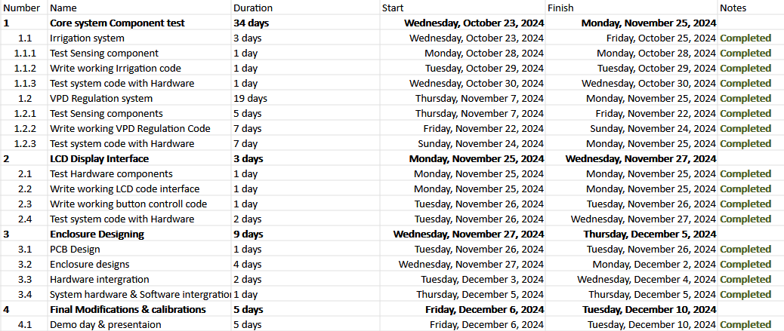

# Final Code:

[**Code link**](https://nscc-my.sharepoint.com/:w:/g/personal/w0483982_campus_nscc_ca/EeEkQibWLmxGjimORUgAY8QBQhqj52tNqU2fuwianyllIQ?e=0SyNpm)

# Hardware Design:

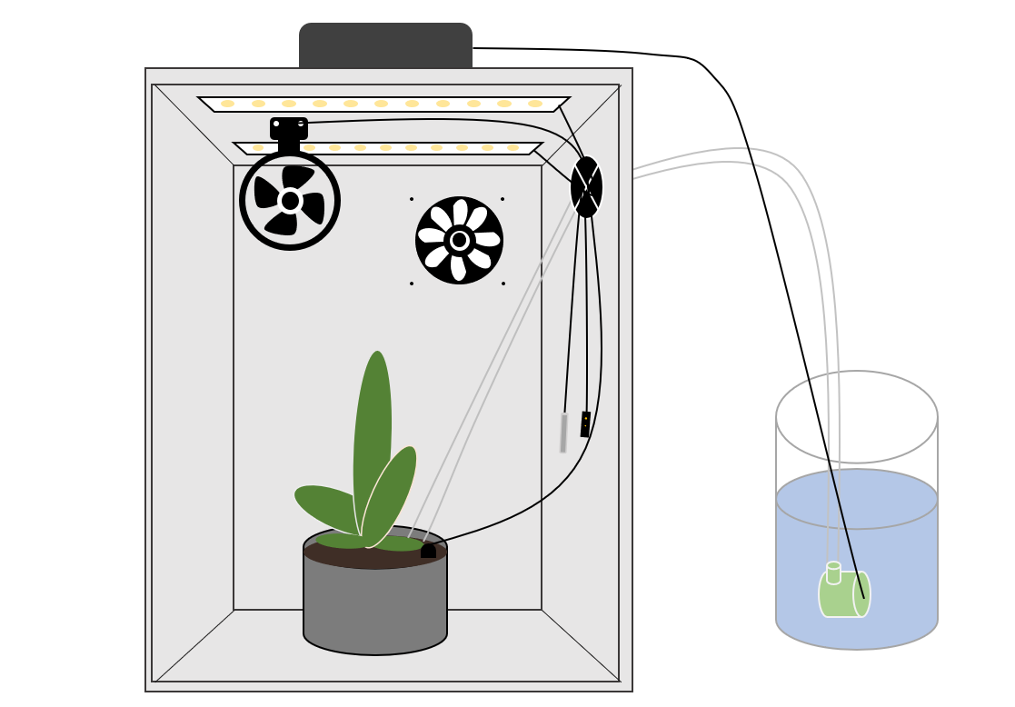**Figure 1 – PLANT Enclosure BuilD**

**Figure 2 – Electronics enclosure Top**

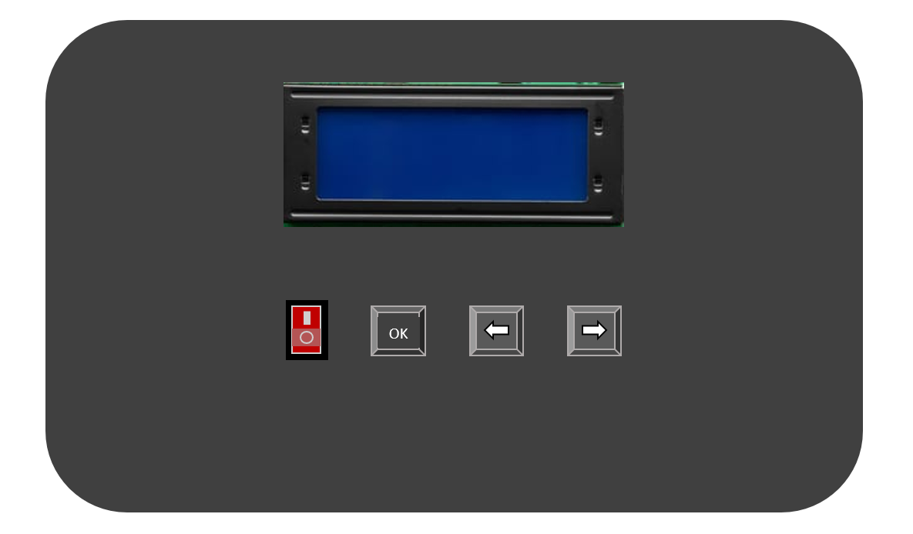

**Figure 3 – Electronics enclosure BACK**

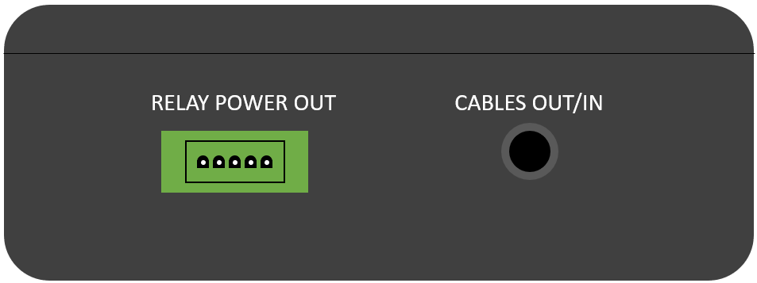

**Figure 4 – ciRCUIT Board Layout**

|  |  |  |  |
| --- | --- | --- | --- |
| Item | Qty | Part Number | Description |
| 1 | 1 | **PB187-6** | **Intake Fan** |
| 2 | 1 | **FBL09A12H** | **Exhaust Fan** |
| 3 | 1 | **27976** | **Parallax Serial LCD** |
| 4 | 1 | **Pic18f45k20** | **Microcontroller** |
| 5 | 1 | **PT100 RTD** | **Temperature sensor** |
| 6 | 1 | **HIH- 4010** | **Humidity Sensor** |
| 7 | 1 | **SEN0193** | **Soil Moister Sensor** |
| 8 | 1 | **Fp0125 LM7805C** | **12V to 5V voltage regulator** |
| 9 | 1 | **BCM394E TLV2217-33** | **12V to 3.3V voltage regulator** |
| 10 | 2 | **JT-DC3V-4.5** | **5V Relay** |
| 11 | 2 | **Kullsinss LED Grow Lights** | **Grow Lights** |
| 12 | 1 | **JT-DC3W** | **Mini Water Pump** |
| 13 | 1 | **TP30** | **Vinyl Tubing** |
| 14 | 1 | **EADP-30FB A** | **Power brick 12V** |
| 15 | **1** | **Single pole** | **Switch** |
| 16 | **3** | **Push Button** | **Key button(1,2,3)** |
| 17 | **3** | **USB Port** | **Repurposed USB Port** |
| 18 | **1** | **AD623** | **Instrumentation Amplifier** |
| 19 | 2 | **UXB02070F1000BR100** | **100 Ω Resistor(R3,R4)** |
| 20 | 1 | **3362p** | **100 Ω Adjustable pot(R2)** |
| 22 | 1 |  | **100k Ω Adjustable pot(R2)** |
| 23 | 3 | **CF14JT10K0** | **10k Ω Resistor (R1,R7,R10)** |
| 24 | 1 | **MFR-25FTF52-65K** | **65k Ω Resistor (R9)** |
| 25 | **5** | **UKT1H0R1MDD1TD** | **0.1uF Capacitor(C2,C3)** |
| 26 | **2** | **URS1HR33MDD1TD** | **0.33uF Capacitor(C1,C3)** |
| 28 | 1 | **URZ1HR22MDD1TD** | **22uF Capacitor (C4)** |
| 29 | 1 | **TBD** | **Water Tank** |
| 30 | 1 |  | **4 Terminal connectors** |

**Table 1 – PARTS list**

**Figure 5 – Circuit Schematic**

# Test Procedures:

|  |  |  |  |
| --- | --- | --- | --- |
| **Test** | **Requirement** | **Test Steps** | **Pass/Fail** |
| **1** | **1, 4** | Turn on the device with on/off switch and see if LCD screen is on. LCD should start by giving you the first prompt for setup. That will show that device received the power required for it to work. |  |
| **2** | **1, 4** | After turning device on go through setup prompts that tell you to put temperature, humidity and moisture (Make sure that the water pump tubing is put in the plant already together with moisture sensor). After that it should show the screen confirming inputted values with threshold VPD and then will show real time measurements and measured VPD value. That will show that buttons are working. |  |
| **3** | **2** | To test temperature and its regulation by fan, hold the temperature sensor in your hand or other warm object that is warmer than the threshold temperature from setup prompt, and keep it on sensor. If LCD shows that temperature went higher and regulation fan is spinning, then everything works. |  |
| **4** | **2** | To test humidity and its regulation by fan, exhale on the humidity sensor or use some other means to give vapor to sensor to test the threshold humidity from setup prompt. If LCD shows that humidity went higher and regulation fan is spinning, then everything works. |  |
| **5** | **2** | To test moisture and its regulation by water pump, put water pump tubing into some container that would hold water. Then hold the moisture sensor in the air (make sure that there is no water on it) to test the threshold moisture from setup prompt (it will make moisture go to 0% or close to it). If LCD shows that humidity went higher and pump starts to putout water then its good. To test if pump can stop pumping water, put sensor in water. If water stops coming out of pump, then everything works. |  |
| **6** | **3** | To test the lights, make sure it’s powered through USB power brick. Then when its light up, through light controller buttons, configure the lights to a needed configuration (select light color, dimming and light cycle). When setup is complete, the light color and dimming should be visible right away, but the light cycle can be only checked after one is complete (if placed for 6 hours, then check the lights after 6 hours of work, it should be off by then). |  |
| **7** | **3** | To test the circulation fan, use same procedure as for temperature and humidity regulation fan, logic should be same for both. |  |